Time Series AAPL

Table of Contents
Abstract 4
Problem Description and Methodology 4
Problem Description 4
Methodology 4
Forecast Objective 6
Activity 1 6
Exploratory Data Analysis 6
Time Series Visualization 7
Time Series Decomposition 8
Multiplicative Decomposition 9
Additive Decomposition 10
Conclusion from Decomposition 11
Forecast Evaluation Metrics 11
Naive Method 12
Fit and forecast and Visualization 12
Accuracy metrics 13
Comments 13
Average Historical Method 13
Fit, forecast and visualization 13
Accuracy Metrics 14
Comments 14
Simple Average Method 15
Fit, forecast and visualization 15
Accuracy Metrics 15
Comments 16
Moving Average Forecast 16
Exponential Smoothing methods 17
Single Exponential Smoothing 17
Fit, forecast and visualization 17
Accuracy Metrics 18
Comments 18
Holt’s Linear 18
Fit, forecast and visualization 18
Accuracy Metrics 19
Comments 19
Holt-Winters 20
Fit, forecast and visualization 20
Accuracy Metrics 20
Comments 21
Activity 2 21
ACF and PACF Plots (First Differenced series) 22
ARIMA (0,1,0) 23
Fit, forecast and visualization 23
Accuracy Metrics 24
SARIMA 25
Fit, forecast and visualization 25
Accuracy Metrics 25
Comments 26
Activity 3 27
a. Regression Model Specification and Justification 27
b. Model summary and coefficient interpretation 27
c. Forecasting using the regression model 29
d. Interpretation: accuracy, assumptions, interpretability, and usefulness 32
Conclusion 32
References and Bibliography 33
Data Source 33

Abstract
This report presents a comprehensive time series analysis of the monthly closing stock prices of Apple Inc. (AAPL), a leading multinational technology company and one of the most actively traded stocks in global financial markets, covering the period from January 2021 to January 2026. The dataset consists of monthly observations of stock prices, with the closing price used as the primary variable for analysis and forecasting. The objective of the study is to develop and compare multiple forecasting models to predict stock prices six months ahead. Eight forecasting methods are implemented across three analytical categories: baseline techniques (Naïve, Average, Simple Exponential Smoothing, Holt’s Linear Trend, and Holt–Winters), statistical time series models (ARIMA and SARIMA), and a regression-based approach incorporating lagged variables.

Problem Description and Methodology

Problem Description
Stock price forecasting is a fundamental problem in financial analytics, as accurate forecasts can support investment planning and risk assessment. This study focuses on forecasting the monthly closing stock price of Apple Inc. (AAPL) using historical time series data. The objective is to model the temporal patterns present in the data and generate reliable short-term forecasts.
The data used in this study were collected from NASDAQ and consisted of five years of historical daily stock price data for Apple Inc. (AAPL). Since the analysis required monthly observations, the daily prices were converted to a monthly frequency by retaining only the last trading day of each month, a standard approach in financial time series analysis.

Methodology
The methodology of this study consists of four main stages: data collection, preprocessing, analysis, and results presentation. Following data preparation, exploratory data analysis was conducted to examine key characteristics of the monthly time series, including trend, seasonality, and temporal dependence. Based on these insights, multiple forecasting techniques were implemented. Model performance was evaluated using standard forecast accuracy measures, and the results were presented through tables and visualizations. Code is shown in Exhibition 1. This code resulted in 61 monthly observations spanning from January 2021 to January 2026.
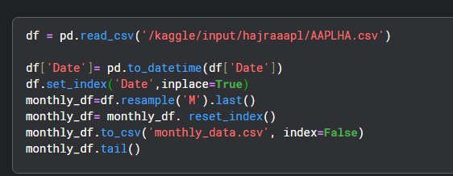
Exhibition 1
The processed data were imported into the analysis environment and stored in a pandas Data Frame named HA using code in Exhibition 2.
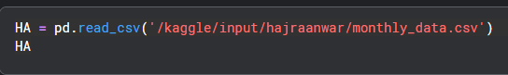
Exhibition 2
The data needed cleaning before analysis. Unnecessary columns were removed, keeping only Date and Close Price. During preprocessing, the Close Price column was found to contain dollar sign symbols ($), causing it to be interpreted as an object rather than a numeric variable. These symbols were removed, and the column was converted to a numeric data type to enable quantitative analysis. Data cleaning and preprocessing steps were implemented using the codes shown in Exhibitions 3 and 4.
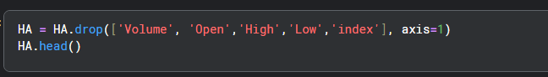
Exhibition 3
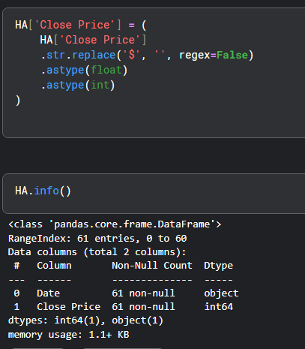
Exhibition 4
The Date column was converted and set as the index to enable time series analysis, as shown in Exhibitions 4 and 5, after which the dataset was ready for forecasting.
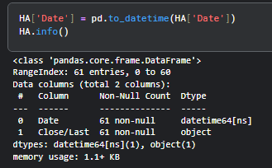
Exhibition 5
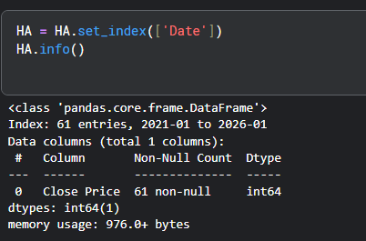
Exhibition 6

Forecast Objective
The primary objective of this study is to develop predictive models capable of accurately forecasting Apple Inc. stock prices. A six-month forecasting horizon was selected as it provides a balance between short-term actionability and sufficient lead time for strategic decision-making, while remaining within a timeframe in which historical patterns are likely to remain relevant.

Activity 1

Exploratory Data Analysis
Exploratory Data Analysis (EDA) was conducted to gain an initial understanding of the distribution, variability, and overall behavior of (AAPL) prior to time series modeling. Both descriptive statistics and graphical visualization techniques were employed to examine the central tendency, dispersion, and potential anomalies in the data.

Descriptive Statistics
The results in Exhibition 7 indicate a right-skewed distribution that is consistent with the overall upward trend in stock prices over time. The most frequently occurring price corresponds to values observed in the earlier part of the series, further reflecting long-term price growth. The boxplot indicates that the median monthly closing price is approximately 175, with an interquartile range (IQR) spanning roughly from 150 to 210. The whiskers extend from about 120 to 280, capturing periods of both relatively low and high price levels over time. No extreme outliers are observed; does not require special treatment prior to forecasting.

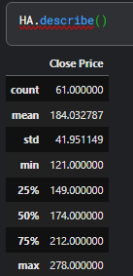 | 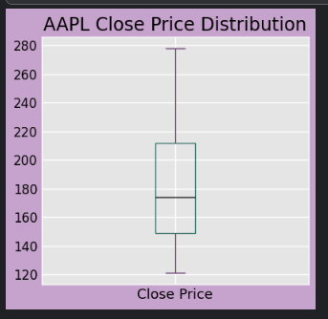
Exhibition 7

Time Series Visualization
The time series plot of Apple Inc. (AAPL) monthly closing prices from 2021 to 2026 (Exhibition 8) shows a clear upward long-term trend, indicating non-stationarity. Short-term fluctuations suggest temporal dependence in the data. While the plot highlights overall variability and trend dominance, it does not clearly isolate seasonal effects, motivating further analysis using decomposition and forecasting models, supporting the use of forecasting models that capture trend and temporal dependence.
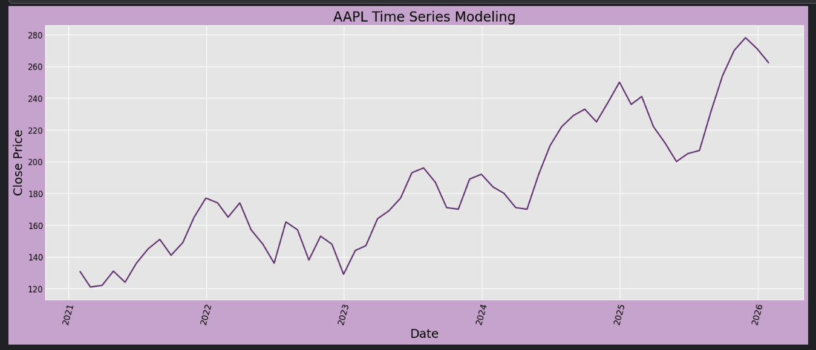 Exhibition 8
Data Split
An 80/20 train–test split was used, corresponding to 54 training and 6 test observations (Exhibition 9).
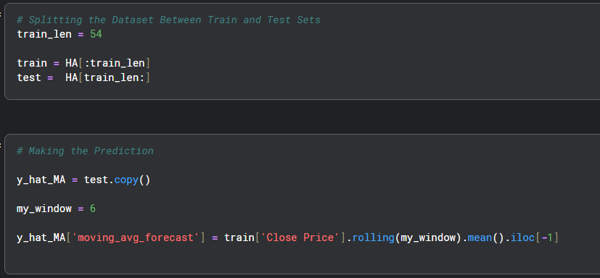
Exhibition 9

Time Series Decomposition
The series was decomposed into trend, seasonal, and residual components, as shown in Exhibitions (10 – 12). The trend shows a steady upward movement, confirming non-stationarity, while the seasonal pattern remains stable over time. Residuals fluctuate around zero with no clear structure, indicating that most systematic variation is captured by the trend and seasonality.
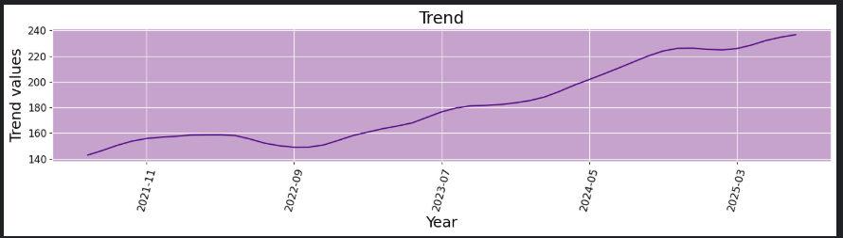
Exhibition 10
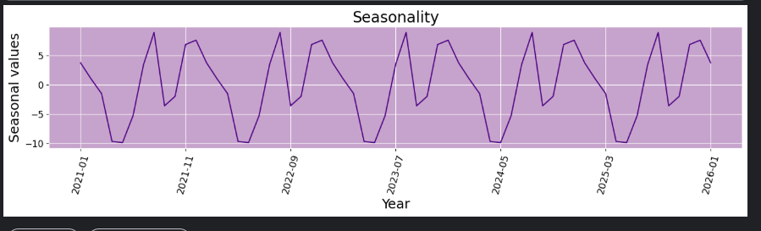
Exhibition 11
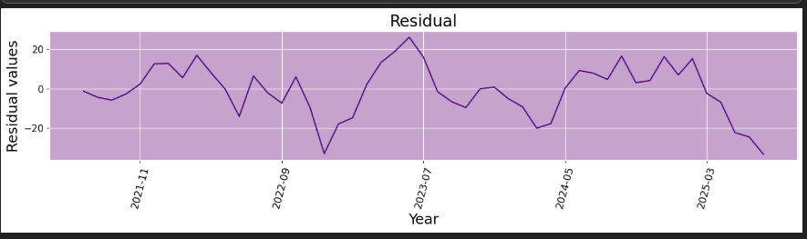
Exhibition 12

Multiplicative Decomposition
As shown in Exhibition 13, it varies slightly around one, indicating that seasonal effects remain stable over time. This suggests that seasonality does not increase with the level of the series, making a multiplicative structure less suitable for this data.
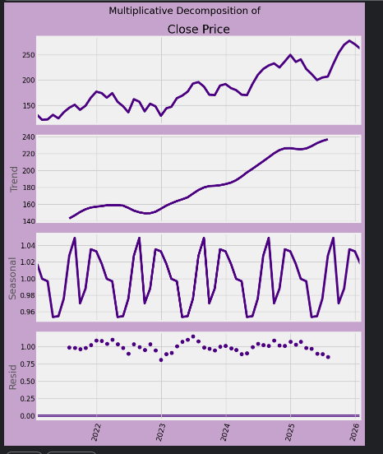
Exhibition 13

Additive Decomposition
The additive decomposition in Exhibition 14 clearly captures the structure of the series. The trend reflects the strong upward movement in prices, while the seasonal component remains stable. Residuals fluctuate around 0 without any clear pattern, supporting the suitability of an additive structure.
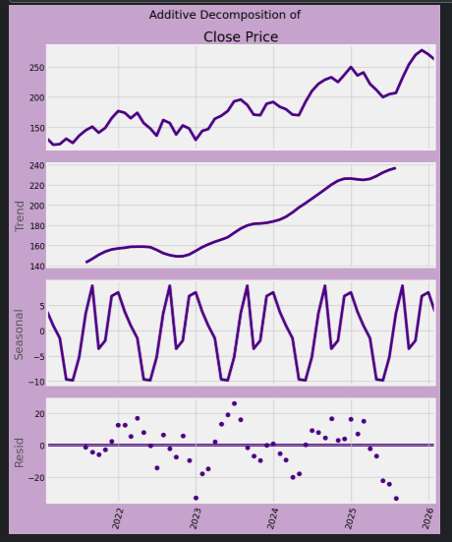
Exhibition 14

Conclusion from Decomposition
Taken together, the decomposition results indicate a strong upward trend, stable seasonal patterns, and irregular residual variation. These characteristics support the use of additive seasonal forecasting models.

Forecast Evaluation Metrics
To ensure consistent evaluation across all forecasting models, a custom function named forecast_accuracy was implemented, as shown in Exhibition 15. The function calculates MAE, RMSE, and MAPE for each model, while storing the results in a table that is presented at the end of the analysis to enable clear and direct comparison of forecasting performance across methods.
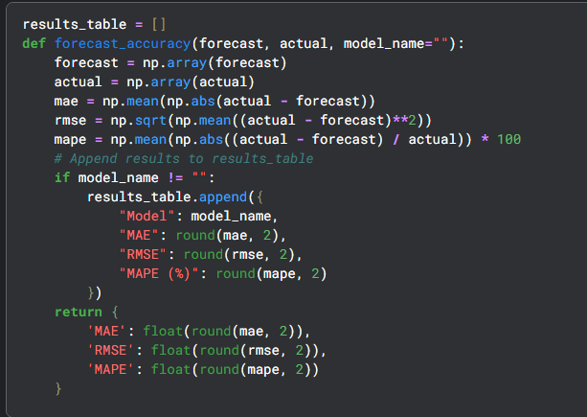
Exhibition 15

Naive Method
The Naive method was fitted using the last observation from the training dataset as the forecast for all future periods. This method is included as a simple baseline benchmark to assess.

Fit and forecast and Visualization
The final training value (207) was repeated as the forecast for each of the six months, resulting in a constant forecast across the horizon, as reported in Table below.
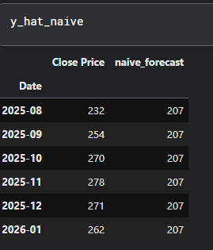
As illustrated in Exhibition 16, the forecast appears as a horizontal line, while the actual test values continue to rise and fluctuate.
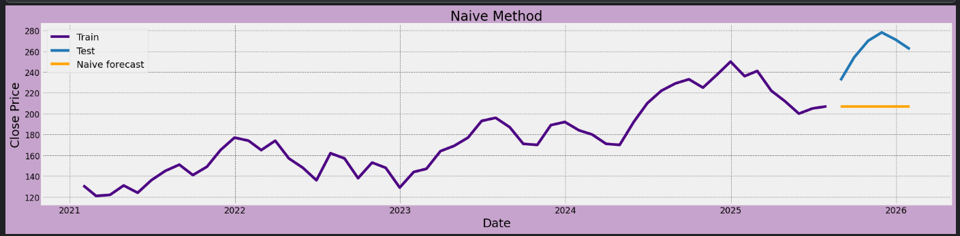
Exhibition 16

Accuracy metrics
Forecast accuracy was computed with the function as shown in Exhibition 17.
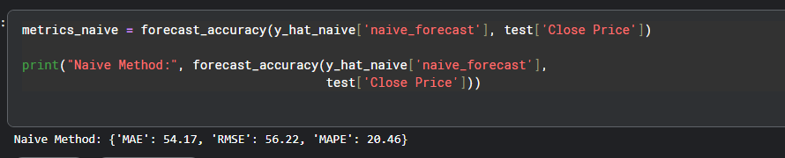 Exhibition 17

Comments
The relatively high error values confirm that the Naive method cannot capture the strong upward trend and variability in the series, reinforcing its role as a baseline reference model rather than a reliable forecasting approach.

Average Historical Method
The method forecasts future values using the mean of all historical closing prices in the training dataset.

Fit, forecast and visualization
The historical average of the training data (175.62) was forecasted, as illustrated in Table below.
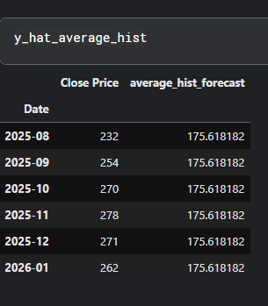
As illustrated in Exhibition 18, the forecast appears to be a flat horizontal line positioned well below the actual test values, highlighting the divergence between the constant forecast and the rising observed prices.
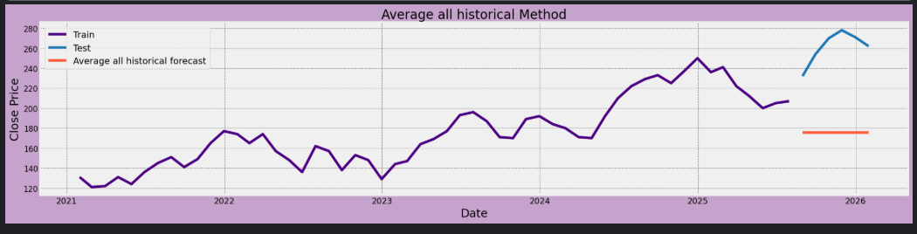 Exhibition 18

Accuracy Metrics
As shown in the Exhibition 19, the Average Historical method produced high error values, indicating poor predictive performance.
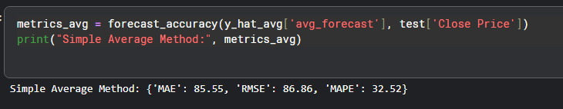 Exhibition 19

Comments
The high error values confirm that relying on a single historical average is not suitable for this dataset. The Average Historical method serves primarily as a baseline reference rather than a practical forecasting tool.

Simple Average Method
The Average Historical method forecasts future values using the mean of all historical closing prices in the training dataset, does not account for trends or seasonality.
This method is included as a simple baseline approach to assess whether using the overall historical average provides an improvement over the Naive method.

Fit, forecast and visualization
The historical average of the training data (175.62) as reported in Table below.
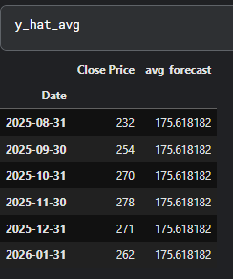
As illustrated in Exhibition 20, the Average Historical forecast appears as a flat horizontal line positioned well below the actual test values. The method’s inability to reflect recent changes in the series.
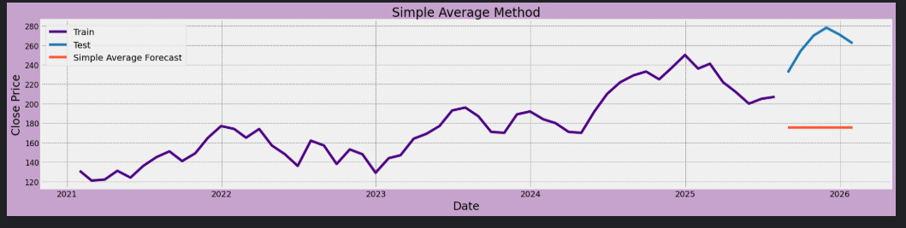 Exhibition 20

Accuracy Metrics
The Average Historical method indicates poor predictive performance (Exhibition 21). These results show that relying on a single historical average is unsuitable for this dataset, which exhibits strong upward trends and variability.

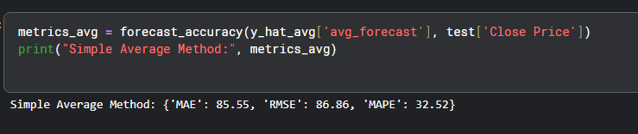
Exhibition 21

Comments
The high MAE and RMSE values indicate that it does not follow the upward trend in prices.
The MAPE of 32.52% shows that this method performs poorly for this dataset and is not suitable for accurate forecasting.

Moving Average Forecast
The code (Exhibition 22) generates a constant six-period moving average forecast, and Exhibitions 23–24 show that this results in a flat forecast value of 219.33 across the horizon, failing to capture the upward trend and variability in the actual closing prices.

Exhibition 22

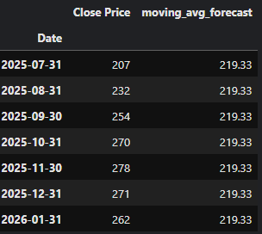
Exhibition 23
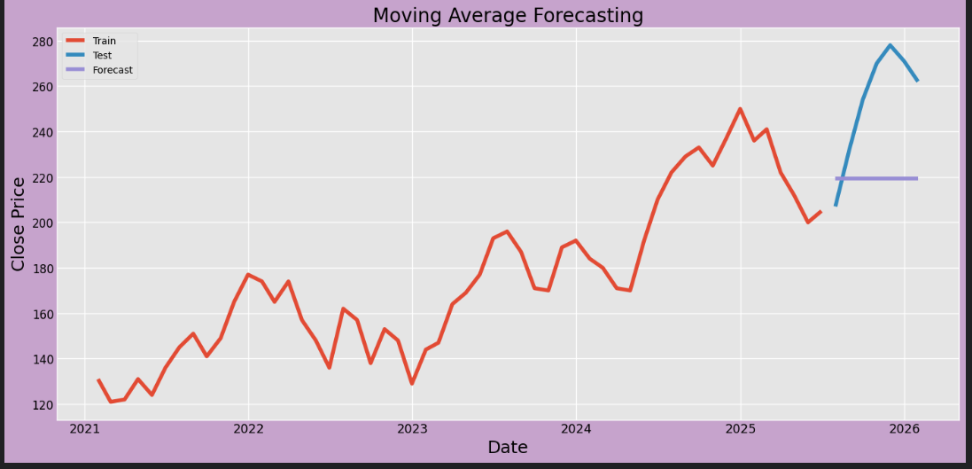
Exhibition 24

Exponential Smoothing methods

Single Exponential Smoothing
SES was fitted with trend smoothing parameters automatically optimized using built-in optimization routines.

Fit, forecast and visualization
SES applies exponentially decreasing weights to past observations, giving more importance to recent values while modeling only the level of the series. The resulting forecast repeats the estimated level (207.0) for each of the six forecast months, as shown in table below.
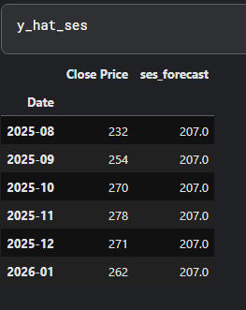
Exhibition 25 illustrates that SES forecast is a smooth horizontal line. While the forecast follows the general level of the series more closely than simple average methods, it does not track the continued upward movement observed in the actual test values.
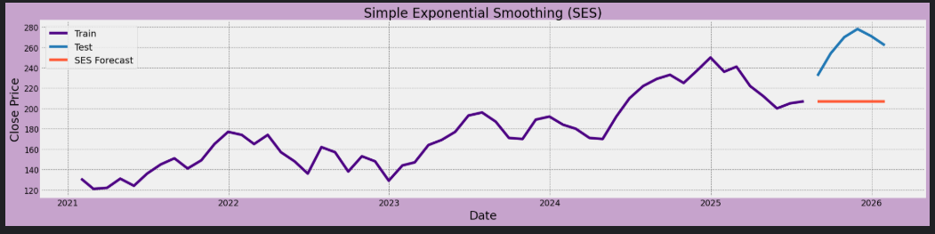 Exhibition 25

Accuracy Metrics
The SES model indicates substantial forecast errors relative to the actual closing prices (Exhibition 26).
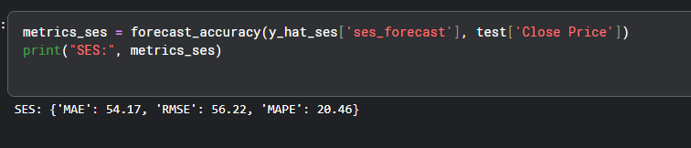
Exhibition 26

Comments
SES struggles to capture the strong upward trend present in the series, leading to high prediction errors. This highlights the need for trend-aware exponential smoothing models in subsequent analysis.
Exponential smoothing methods were implemented following established guidelines [1].

Holt’s Linear

Fit, forecast and visualization
Unlike SES, Holt’s method models both the level and the linear trend of the series. The forecast shows a gradually declining pattern, with forecast values decreasing, as reported in table below.
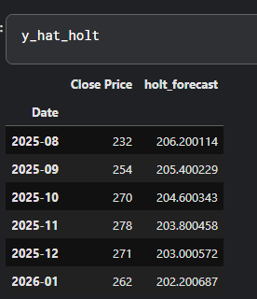
Exhibition 27 illustrates that Holt forecast deviates the actual test values, which continue to rise. While the model captures trend behavior, it does not fully track the magnitude or variability of recent price movements.
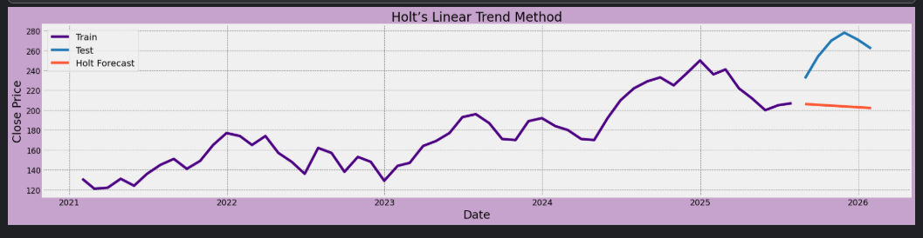 Exhibition 27

Accuracy Metrics
Holt’s Linear method forecast errors remain high despite incorporating a trend component (Exhibition 28).
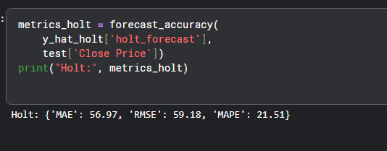
Exhibition 28

Comments
Although Holt’s Linear model improves, still the method does not adequately capture the strength and variability of the upward price movement, indicating that models incorporating seasonality may be more appropriate in subsequent analysis.

Holt-Winters
SES was fitted with trend smoothing parameters automatically optimized using built-in optimization routines.

Fit, forecast and visualization
This method extends Holt’s Linear model by explicitly incorporating seasonality in addition to level and trend, as reported in table below.
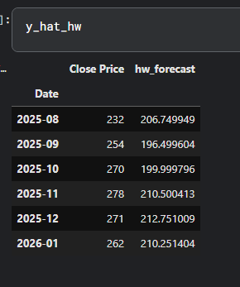
Exhibition 29 illustrates that the forecast captures both the overall upward movement and short-term seasonal variation; however, it still lags at actual test values during periods of rapid price increases.
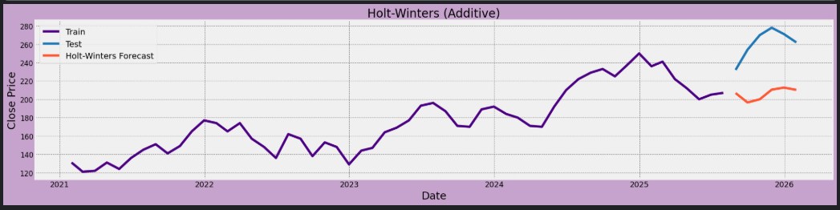 Exhibition 29

Accuracy Metrics
The Holt–Winters model indicates a modest improvement over SES and Holt’s Linear method but still leaves noticeable forecast errors (Exhibition 30).
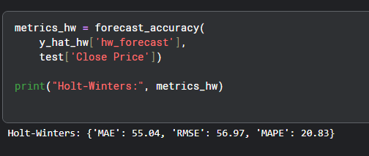
Exhibition 30

Comments
Although Holt–Winters does not fully capture the magnitude of recent price movements in this dataset. While it outperforms simpler baseline methods, its forecasting accuracy remains limited, indicating that more flexible models may be required.

Activity 2
The Augmented Dickey–Fuller (ADF) test was applied to the original closing price series, as shown in Exhibition 31. The ADF statistic was −0.70 with a p-value of 0.85, indicating that the series is non-stationary and contains a unit root, consistent with the presence of a strong trend.
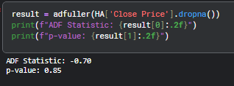
Exhibition 31
The ADF test was then applied to the first-differenced series, as shown in Exhibition 32. The resulting ADF statistic was −6.46 with a p-value close to zero, indicating that the differenced series is stationary.
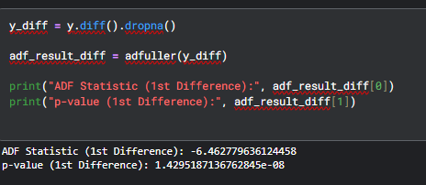
Exhibition 32

ACF and PACF Plots (First Differenced series)
After first differencing, the ACF and PACF plots were examined to guide ARIMA model selection. The ACF shows a significant spike at lag 1 with remaining lags within the confidence bounds as shown in Exhibition 33.

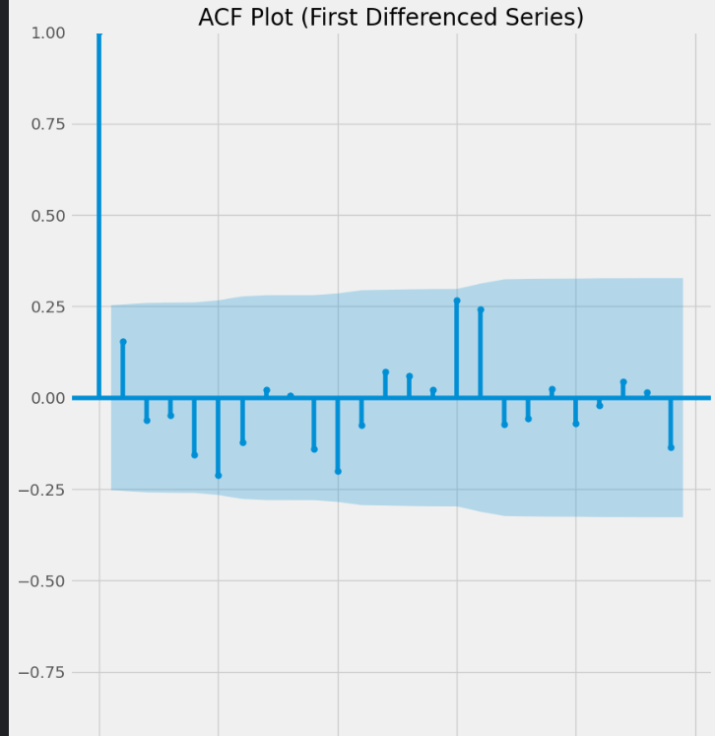
Exhibition 33
The PACF displays a similar pattern. This indicates limited short-term dependence and supports the use of a low-order ARIMA model, as shown in Exhibition 34.
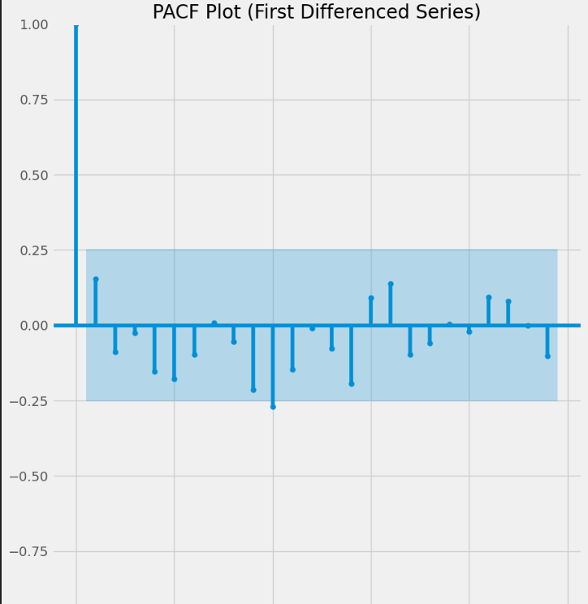
Exhibition 34

ARIMA (0,1,0)
AIC-based grid search over ARIMA (p,1, q)
An AIC-based grid search over ARIMA(p,1,q) models was conducted to identify the optimal specification using code shown in Exhibition 35, with ARIMA (0,1,0) achieving the lowest AIC value and therefore selected as the best-fitting model.
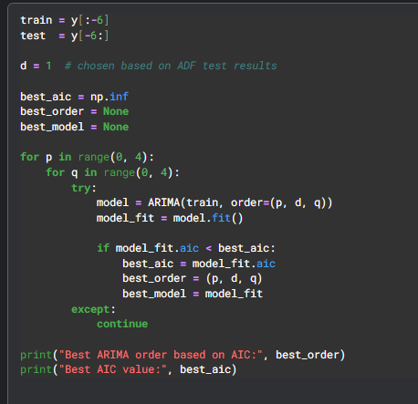

Exhibition 35

Fit, forecast and visualization
The ARIMA(0,1,0) model diagnostics (Exhibition 36) shows that the Ljung–Box p-value is greater than 0.05, indicating no remaining autocorrelation
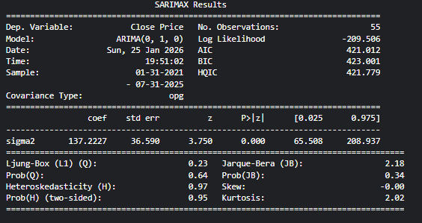
Exhibition 36
As shown in Exhibition 37, the ARIMA(0,1,0) forecast projects a stable continuation of the series but lags the actual values during periods of rapid price increase.
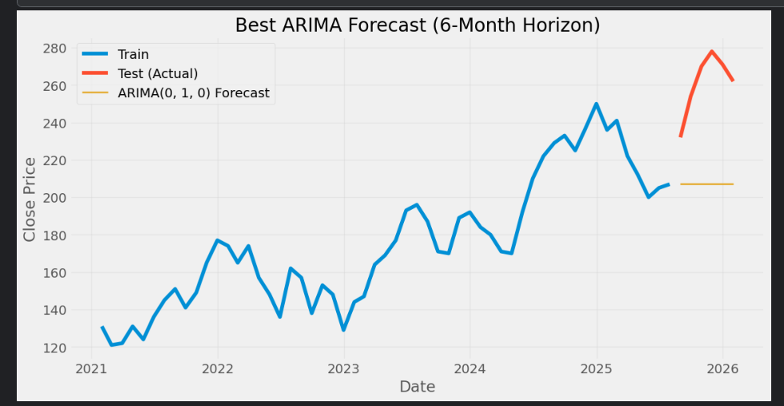
Exhibition 37

Accuracy Metrics
The accuracy metrics indicate moderate forecasting accuracy over the six-month test period.
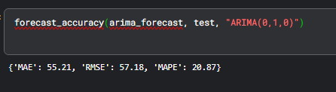
Exhibition 38
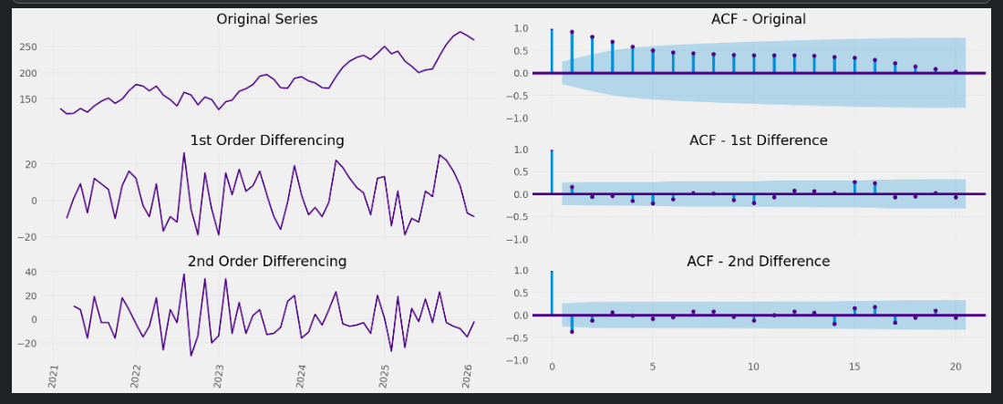
Exhibition 39

SARIMA
The SARIMA model extends ARIMA by explicitly incorporating seasonal autoregressive and moving average components, allowing it to model both trend and seasonality.

Fit, forecast and visualization
Although no strong seasonal pattern was identified, a SARIMA(0,1,0)(1,1,1,12) model was fitted for comparison, allowing assessment of whether including a seasonal component improves forecasting performance. Model estimation results are summarized in Exhibition 40, which reports the fitted parameters and diagnostic statistics.
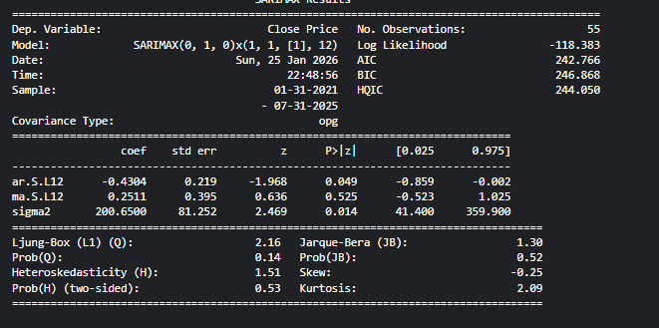
Exhibition 40
Exhibition 41 illustrates that SARIMA forecast captures seasonal variation and follows the general movement of the series more closely than non-seasonal models, producing a varying forecast rather than a flat line over the six-month horizon.
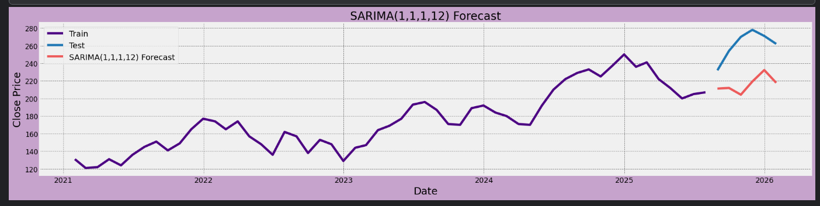 Exhibition 41

Accuracy Metrics
The SARIMA model indicates moderate forecasting accuracy (Exhibition 42). Despite capturing seasonal effects, its performance did not surpass that of the best non-seasonal ARIMA model.

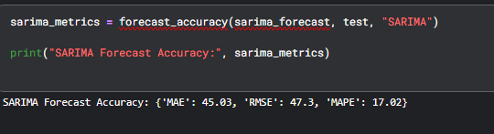
Exhibition 42

Comments
Although SARIMA captures seasonal variation, its forecast errors are higher than those of the non-seasonal ARIMA model, indicating that seasonality does not significantly improve short-term forecasting accuracy for this dataset.
Stationarity testing and ARIMA identification followed standard time-series procedures [2].
Residual Error Diagnostics for the Selected ARIMA Model
Exhibition 43 shows that the residuals fluctuate around zero with no visible pattern, and the residual ACF shows no significant autocorrelation, indicating that the errors behave like white noise. This confirms that the ARIMA(0,1,0) model is statistically adequate as a baseline forecasting model
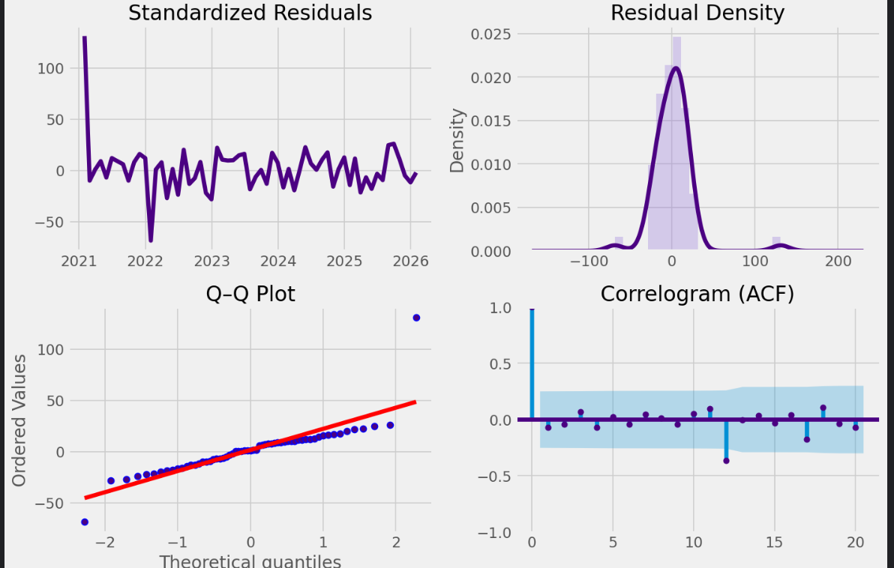
Exhibition 43

Activity 3

Regression Model Specification and Justification
A time series regression model was applied by using lagged values of the Close Price as predictors of the current Close Price. As shown in Exhibition 44, two lag features were created, lag1 (previous month) and lag2 (two months prior), and rows with missing lag values were removed. This lag structure is appropriate for monthly stock prices because the series exhibits temporal dependence, meaning recent months often contain predictive information about the next month. In the final implementation, the Lag 1 model was used for forecasting because it provided strong predictive performance while keeping the model simple and interpretable.
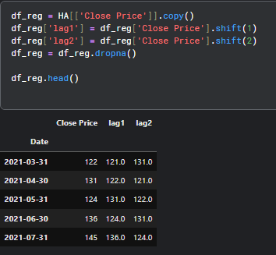
Exhibition 44

Model summary and coefficient interpretation
The OLS regression summary in Exhibition 45 indicates a strong model fit (R-squared = 0.885, Adj. R-squared = 0.883). The lag1 coefficient (0.9242) is statistically significant (p < 0.001), confirming that the previous month’s Close Price is a strong predictor of the current month’s Close Price. The intercept is not statistically significant at the 5% level (p = 0.079), which is acceptable because the explanatory power is primarily captured by the lag term.
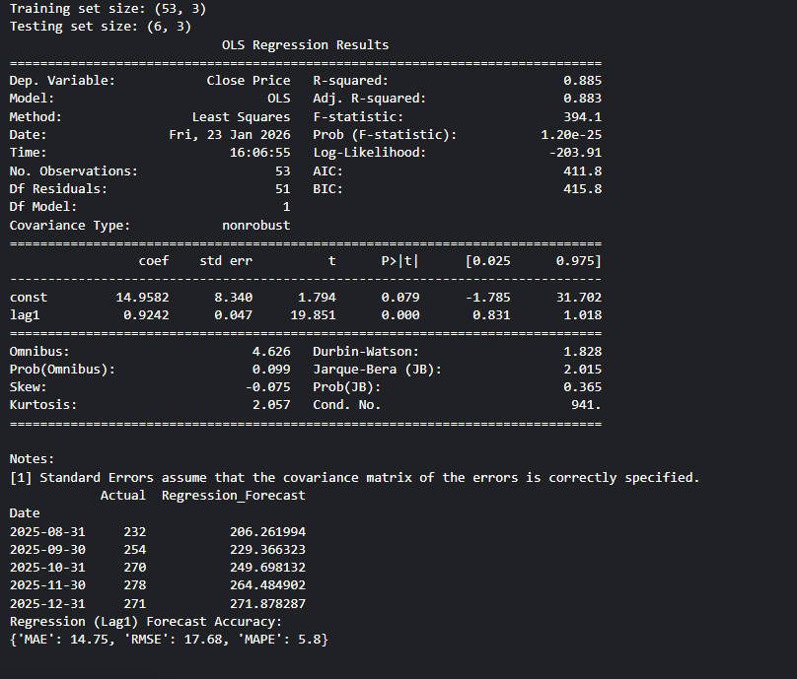
Exhibition 45
Exhibition 46 presents residual diagnostics for the regression model. The residuals fluctuate around zero with no visible trend, the density and Q–Q plots indicate approximate normality, and the residual ACF shows no significant autocorrelation. These results suggest that the regression model assumptions are satisfied.

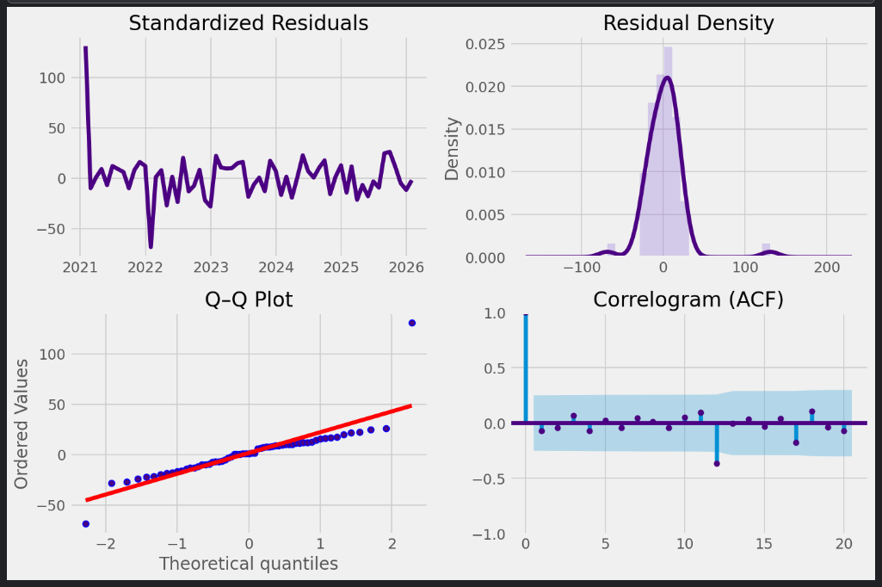 Exhibition 46

Forecasting using the regression model
The fitted Lag 1 regression model was then used to generate six-month forecasts for the test period, where the regression forecast follows the test segment more closely than baseline methods.
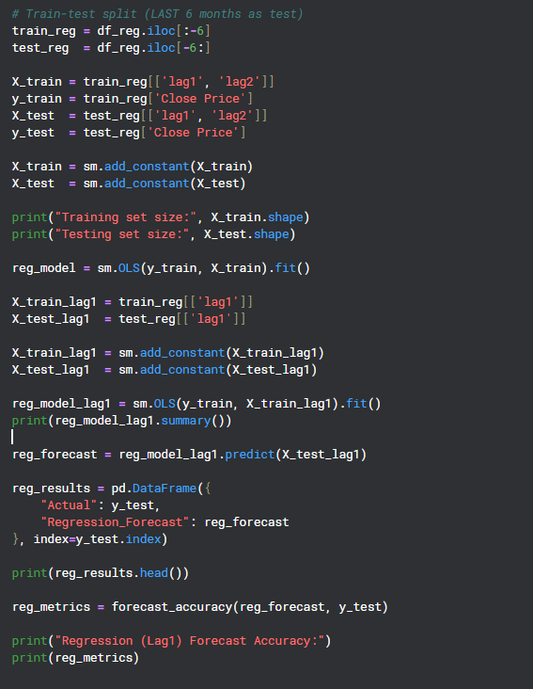
Exhibition 47

The forecasted values were reported alongside actual values in table below and visualized in Exhibition 48, where the regression forecast follows the test segment more closely than baseline methods.
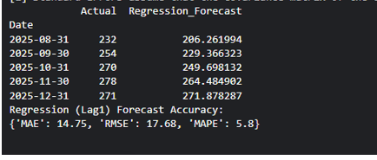
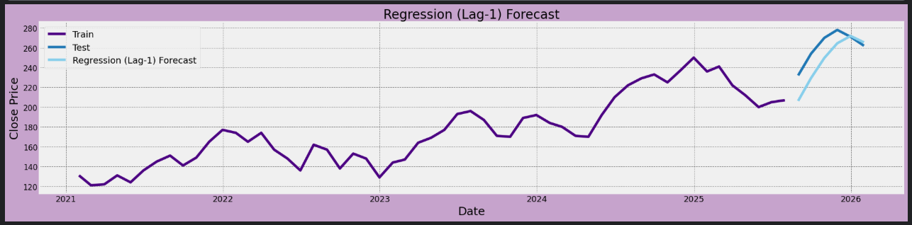 Exhibition 48
Performance comparison with Activity 1 and Activity 2 models
The regression model outperforms the benchmark and ARIMA-family models included in Activity 1 and Activity 2. This is also supported by the RMSE comparison chart in Exhibition 49, where the regression model shows the lowest RMSE.
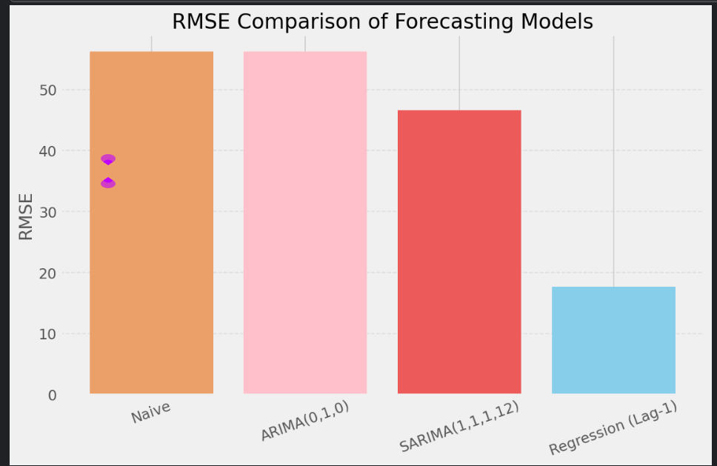 Exhibition 49

Interpretation: accuracy, assumptions, interpretability, and usefulness
Overall, the regression model delivers the most accurate short-term forecasts by exploiting strong persistence in monthly closing prices, with predictions driven by the previous month’s value. While the model is simple and interpretable, its performance depends on the stability of this relationship and may weaken during structural breaks or sudden market shifts, making it most effective when used alongside other models in volatile conditions.

Conclusion
This report compares several forecasting approaches for Apple Inc.’s monthly closing prices (Exhibition 50-51). Baseline and smoothing methods perform poorly as they fail to capture the strong trend in the data. SARIMA improves the non-seasonal ARIMA model by incorporating weak seasonal effects, though these do not dominate price movements. Overall, the lag regression model delivers the lowest forecast errors and is the most effective approach for short-term forecasting in this analysis.
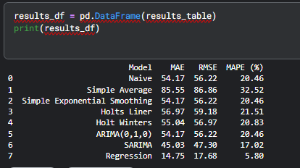
Exhibition 50
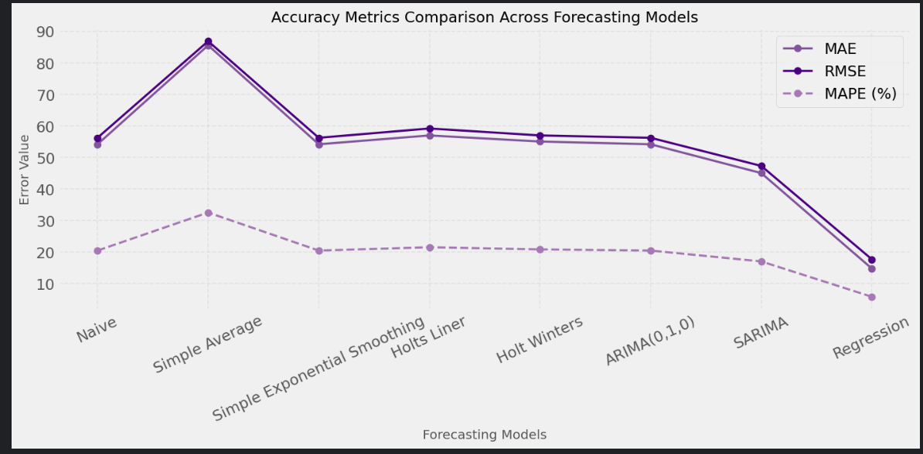
Exhibition 51

References and Bibliography
- Hyndman, R. J., & Athanasopoulos, G. (2021). Forecasting: Principles and practice (3rd ed.). OTexts. https://otexts.com/fpp3/
- Shumway, R. H., & Stoffer, D. S. (2017). Time series analysis and its applications: With R examples (4th ed.). Springer. https://doi.org/10.1007/978-3-319-52452-8
(Note: Online materials updated through 2022)
- Wei, W. W. S. (2019). Time series analysis: Univariate and multivariate methods (2nd ed.). Pearson Education.

Data Source
NASDAQ. (2026). Apple Inc. (AAPL) Historical Stock Prices. Retrieved from https://www.nasdaq.com/market-activity/stocks/aapl/historical.

